**TERM 1. (August 24-Sept 16 2020)**

**Module Outcome:**

Explain the different political and economic actors and institutions in the global system, their respective roles and functions, and their relations in the context of the COVID-19 pandemic.

**Learning Objectives**

*Preliminaries:* Course Orientation; USC’s Mission-Vision; Institutional Outcome; SAS & DGEM’s Mission and Vision

1) Discuss the ACR (Awareness, Choice, and Responsibility) Approach as a framework to understanding the contemporary world

2) Determine the different and relevant transformations that have happened over the years

3) Recognize globalization as the ongoing movement that has affected many aspects of one’s everyday life

4) Describe globalization as an economic, political, and socio-cultural process

**MODULE 1.1** **The ACR (Awareness-Choice-Responsibility model)**

***Video*:** “The Howl and the Fussyket”

<https://www.youtube.com/watch?v=0323YBGFdtg>

*Discussion:*

* What do you mean by “awareness” “choice” and “responsibility”?
* How, if at all, are ACR exemplified in the short movie?
* How may you apply the ACR model in your day-to-day experiences?
* The ACR model as a tool in looking into the contemporary world

**MODULE 1.2** **The Concept of Globalization and its Metaphors**

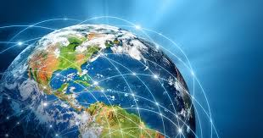newamerica.org

***Activity 1.2.1:***

What gadgets do you have there? Where did these products came from?

How are these gadgets affecting your daily life?

Can you live without them? Why or why not?

***Content:***

Definitions of Globalization

What is Globalization?

Globalization as a Contested Term

Why is Globalization a Contested Term?

Metaphors of Globalization

*Discussion:* The Elephant and the Blind Men

*Activity:* What is your metaphor of globalization and why?

Globalization: Revisiting some Significant Turning Points in History

*READING:* A Brief History of Globalization in [https://www.weforum.org/agenda/2019/01/how-globalization-4- 0-fits-into-the-history-of-globalization/](https://www.weforum.org/agenda/2019/01/how-globalization-4-%090-fits-into-the-history-of-globalization/)

*Short Video*: How the Ancient Silk Road Pioneered Globalization in <https://www.youtube.com/watch?v=cHSgkZsCgtw>

PPt: Introduction to Globalization

**MODULE 1.3** **The United Nations and Global Governance**

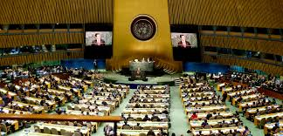umjustce.org

*Content:*

* What is the UN about? Who are there and why?
* [www.un.org](http://www.un.org)
* UN ppt
* Supporting videos:

<https://www.youtube.com/watch?v=1cqw8-ongtY>

<https://www.youtube.com/watch?v=QoIafzc0k74>

**MODULE 1.4** **Globalization of Markets and Economic Relations**

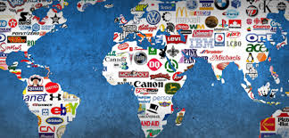ifranchise.ph

* Of Corporations and Countries

Read: 69 of the Richest 100 Entities are Corporations

<https://www.globaljustice.org.uk/news/2018/oct/17/69-richest-100-entities-planet-are-corporations-not-governments-figures-show>

Video: Most Powerful Corporations of the World? <https://www.youtube.com/watch?v=JV1NB70gLQI>

**MODULE 1.5** **Regional Organizations and Regionalism**

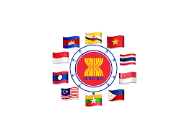aseanusmission.gov

* The ASEAN and the ASEAN integration

[www.asean.org](http://www.asean.org)

**References**:

Conales, Donaire, Estanda, et. Al (2018). The Contemporary World: Awareness, Choice and Responsibility. Cebu City: University of San Carlos Press. [pp. 1-60]